PIZZA SALES SQL QUERIES
KPI’s
1.Total Revenue
SELECT SUM(total_price) as total_revenue from pizza_sales;
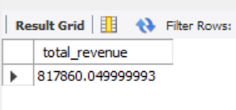
2.Average Order Value
SELECT SUM(total_price)/ COUNT(DISTINCT order_id) as Avg_order_value from pizza_sales;
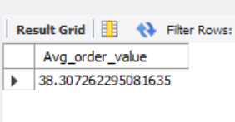
3.Total Pizza Sold
SELECT SUM(quantity) as Total_pizza_ordered from pizza_sales;
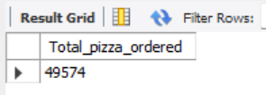
4.Total Order
SELECT COUNT(DISTINCT order_id) as Total_order from pizza_sales;
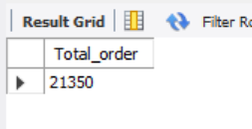
5.Average Pizza’s per Order
SELECT SUM(quantity)/ COUNT(DISTINCT order_id) as Avg_pizza_per_order from pizza_sales;
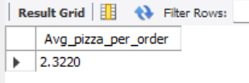
CHART REQUIREMENTS
6.Daily Trends for total order
SELECT DAYNAME(str_to_date(order_date, '%d-%m-%y')) as order_day, COUNT(DISTINCT order_id) as Total_orders
from pizza_sales
GROUP BY DAYNAME(str_to_date(order_date, '%d-%m-%y'));
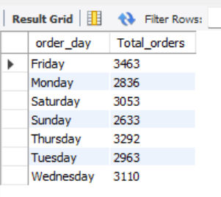
7.Monthly Trends for orders
SELECT MONTHNAME(str_to_date(order_date, '%d-%m-%y')) as month_name,
COUNT(DISTINCT order_id) as Total_orders
from pizza_sales
GROUP BY month_name;
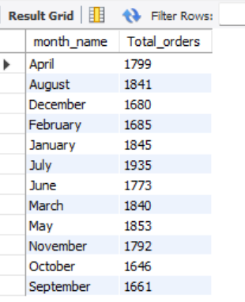
8.Percentage of Sale by pizza category
SELECT pizza_category, SUM(total_price) * 100 / (SELECT SUM(total_price) from pizza_sales) as PCT
from pizza_sales
GROUP BY pizza_category
ORDER BY PCT DESC;
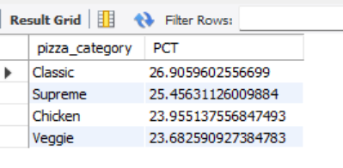
9.Percentage of sale by pizza size
SELECT pizza_size, CAST(SUM(total_price) as decimal(10,2)) as Total_sales,
CAST(SUM(total_price) * 100 / (SELECT SUM(total_price) from pizza_sales) as decimal(10,2)) as PCT
from pizza_sales
GROUP BY pizza_size
ORDER BY PCT DESC;
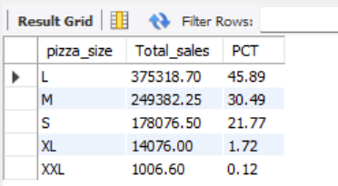
NOTE:
If we want to apply the Month, Quarter, Week filters to the above queries we can use WHERE clause. Following some example:
SELECT DAYNAME(str_to_date(order_date, '%d-%m-%y')) as order_day, COUNT(DISTINCT order_id) as Total_orders
from pizza_sales
WHERE MONTH(order_date) =1
GROUP BY DAYNAME(str_to_date(order_date, '%d-%m-%y'));
*Here MONTH(order_date)=1 indicate that the output is for the month of January. ; =4 indicates month of April.

10.Top 5 best seller by Revenue
SELECT pizza_name, SUM(total_price) as total_revenue from pizza_sales
GROUP BY pizza_name
ORDER BY total_revenue DESC
LIMIT 5;
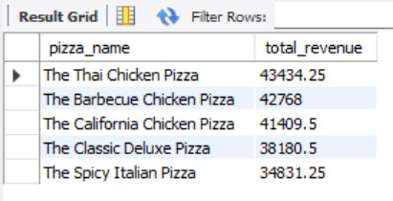
11.Bottom 5 Seller by revenue
SELECT pizza_name, SUM(total_price) as total_revenue from pizza_sales
GROUP BY pizza_name
ORDER BY total_revenue
LIMIT 5;
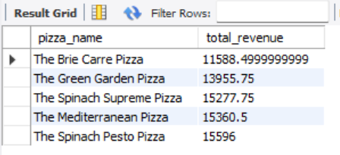
12.Top 5 best seller by Total Quantity
SELECT pizza_name, SUM(quantity) as Total_quantity from pizza_sales
GROUP BY pizza_name
ORDER BY total_quantity DESC
LIMIT 5;
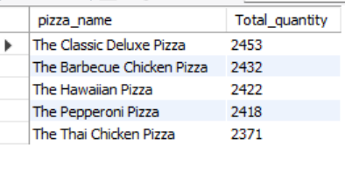
13.Bottom 5 Seller by Total Quantity
SELECT pizza_name, SUM(quantity) as Total_quantity from pizza_sales
GROUP BY pizza_name
ORDER BY total_quantity
LIMIT 5;
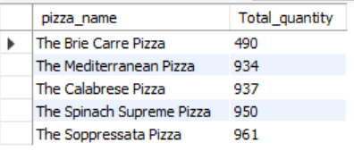
14.Top 5 best seller by Total Order
SELECT pizza_name, COUNT(DISTINCT order_id) as total_order from pizza_sales
GROUP BY pizza_name
ORDER BY total_order DESC
LIMIT 5;
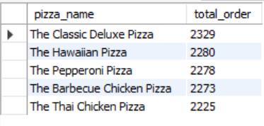
15.Bottom 5 Seller by Total Order
SELECT pizza_name, COUNT(DISTINCT order_id) as total_order from pizza_sales
GROUP BY pizza_name
ORDER BY total_order
LIMIT 5;
